**CURRICULUM VITAE**

APARNA SASI

 [aparnakochu1997@gmail.com](mailto:aparnakochu1997@gmail.com)

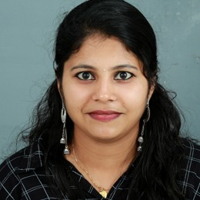 +919497563565

 Udyanasseril,Cheriazheekal P.O,karunagapally,Kollam,PIN:-590673

Udyanasseril Cheriazheekal Karunagapally, kollam Pin : 590673





Objective

As a recent graduate I am seeking a role which allows me to continue learning and perfecting my skills as I provide high quality work and encourages me to ﬂourish as a medical laboratory technician.



Experience

VALIYATH INSTITUTE OF MEDICAL SCIENCE

04/03/2020 - 12/09/2020

LAB TECHNICIAN







REGIONAL PUBLIC HEALTH LABORATORY

-

Lab technician

Specialized in bio chemistry, microbiology, heamatology and pathology.



DISTRICT HOSPITAL KOLLAM

-

Lab technician

Specialized in microbiology, blood bank, bio medical instrumentation and cytology.



REGIONAL CANCER CENTER

-

Lab technician

Specialized in cytogenetic pathology and histopathology.

Education



SME RC ANGAMALY / MAHATMA GANDI UNIVERSITY KOTTAYAM





2020

**BSc MLT**

BSE MLT

**GOVT GIRLS H.S.S THAZHAVA**

GOVT GIRLS H. S. S THAZHAVA

2015 march

PLUS TWO

**GOVT BOYS H.S.S KARUNAGAPALLY**

GOVT N. H. S. S KARUNAGAPALLY

2013 march

S. S. L. C

Skills

Good leadership

Disciplined and punctual Detail conscious





Basic computer skills in MS word and excel. Hard working

Projects



Bacteriological proﬁle of urinary tract infection





Venue : Govt Medical Collage Thrissur

Language

English

Malayalam





Activities

Good listener Dancing

Singing song











Personal Details

Date of Birth : 16/05/1997 Marital Status : Single

Nationality : Indian



Declaration





I hereby declare that all the information contained in this resume is in accordance with facts or truths to my knowledge. I take full responsibility for the correctness of the said information - " "

**Your's Faithfully,**

**APARNA SASI**

